SUBMITTED BY:

AP23110011431-MOUNIKA
AP23110010617-SANJANA
AP23110011630-SAI SREE
AP23110011512-NISHA

Business Summarizer: SUMMAI
Project Description:
The project involves an artificial intelligence-based text summarization system that is capable of converting lengthy business articles, reports, or emails into short, meaningful summaries. Additionally, it uses both extractive and abstractive methods to evaluate their effectiveness. Through a web interface created using Flask, users are able to submit text and the system will promptly produce comprehensible summaries. For preprocessing, modeling, and deployment, the summarizer uses NLP libraries such as NLTK, Sumy, Transformers, and PyTorch.

Project Scenarios
Scenario 1:Business Reports & Emails
Every three months, a 30-page performance report reaches the manager at Amazon. The summarizer transforms it into major metrics and insights, enabling the manager to take fast strategic decisions.
Scenario 2:News & Articles
Every three months, a 30-page performance report reaches the manager at Amazon. The summarizer transforms it into major metrics and insights, enabling the manager to take fast strategic decisions.
Scenario 3: Meeting Transcripts & Notes
At Microsoft Teams meetings, employees produce 2-hour-long transcripts. The summarizer then points out the decisions made, the tasks assigned, and the main discussions, thus facilitating the follow-up process.
Technical Diagram:
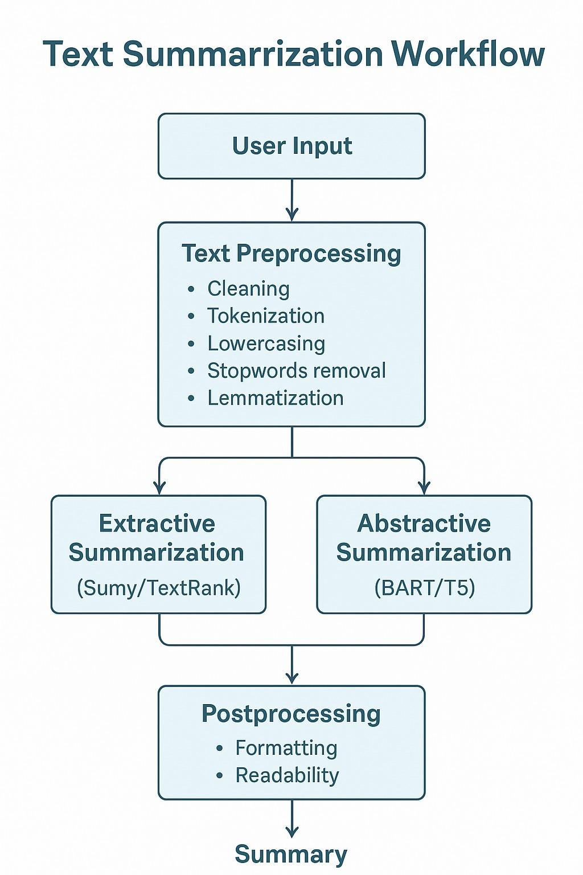
Prerequisites:
- Python installed
- pip package manager
- Virtual environment (recommended)
- Flask
- Transformers
- spaCy
- Sumy
- nltk
- HTML/CSS basics
- Model downloaded (BART)

Prior Knowledge:
You must have prior knowledge of the following topics to complete this project.
● ML Concepts
o Supervised learning: https://www.javatpoint.com/supervised-machine-learning
o Unsupervised learning: https://www.javatpoint.com/unsupervised-machine-learning o Logistic Regression:
https://www.javatpoint.com/logistic-regression-in-machine-learning
o Decision tree:
https://www.geeksforgeeks.org/python-decision-tree-regression-using-sklearn/
o Random forest:
https://www.javatpoint.com/machine-learning-random-forest-algorithm
o Evaluation metrics:
https://www.analyticsvidhya.com/blog/2019/08/11-important-model-evaluation-error
metrics/
o Navie Bayes: https://www.javatpoint.com/machine-learning-naive-bayes-classifier ● Flask Basics: https://www.youtube.com/watch?v=lj4I_CvBnt0
Project Flow:
● The user inputs or uploads lengthy text (articles, reports, or emails) using the web interface.
● The system processes the text by cleaning, tokenizing, and removing stop words, and then it segments the text into sentences.
● The user selects the extractive or abstractive summarizing technique.
● The first one ranks the phrases by their importance via algorithms and the latter one creates a new text that conveys the same idea through the transformer model.
Project Activities:
1 Data Collection & Preparation
- Gather example business articles, reports, and emails for the purpose of training/testing.

- Text data preprocessing: cleaning, tokenization, stop-word removal, and sentence segmentation.

2 Exploratory Data Analysis

- Utilize descriptive statistics (for instance, average sentence length, word frequency) as a method of analysis.
- Give visualization to the significant patterns: word clouds, distribution of sentence importance.
- Determine the text construction for extractive and abstractive summarization case study.

3 Model Building
- Develop extractive summarization based on such algorithms as TextRank or LexRank.

- Develop abstractive summarization through Transformer-based models (for example, BART, T5).

- Adapt the models to the dataset to enhance the relevance of the summary.

4 Performance Testing & Model Selection
- Metrics like ROUGE, BLEU, or cosine similarity will be used for evaluation.

- The outputs of the extractive and abstractive methods will be compared in terms of coherence and informativeness.

- The method that has shown the best performance in the evaluation will be selected for deployment.

5 Model Deployment
- The best model and the preprocessing pipeline are to be saved.

- A Flask web interface will be used for integrating with user input.

- The summary created will be shown along with options to set the length and method of the summary.

- Gunicorn will be the platform for a production-ready deployment.

Project Structure:
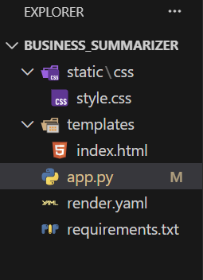

Project Structure Explanation
- static/
Contains CSS, JS, images (UI styling)
- templates/
Contains HTML pages used by Flask (index.html)
- app.py
Connects UI ↔ NLP models (BART + TextRank)
- summarizer.ipynb
Jupyter notebook where you tested models
Milestone 1: Data Collection & Preparation
Gather example business articles, reports, and emails for the purpose of training/testing.
Text data preprocessing: cleaning, tokenization, stop-word removal, and sentence segmentation.
Activity 1: Importing the Libraries
Import the necessary libraries as shown below:
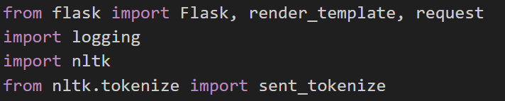
These libraries serve the following purposes:

spaCy
- Used for sentence tokenization
- Helps split long text into meaningful sentences
- Important for extractive summarization

NLTK
- Used for sentence splitting (if needed)
- Used by TextRank/Sumy algorithms
- Provides stopwords and tokenization tools

Sumy / TextRank
- Implements the TextRank algorithm for extractive summarization
- Selects most important sentences based on a graph of similarity
- Lightweight, fast, and reliable

BART (facebook/bart-large-cnn)
- Transformer-based sequence-to-sequence model
- Generates abstractive summaries
- Can create new sentences
T5 (optional comparison)
- Text-to-text transformer model
- Can perform any NLP task by converting input to text
- Larger and more flexible compared to BART

Milestone 2: Exploratory Data Analysis
Before summarization, the text goes through:
1. Sentence Segmentation
spaCy splits the text into sentences:
Required for extractive summarization
Ensures accurate sentence boundaries
2. Tokenization (for BART & Sumy)
Text is broken down into tokens for:
Similarity computation
Model input
3. Stopword Removal (extractive only)
Reduces noise in similarity graphs.

Milestone 3: Extractive Summarization (TextRank/Sumy)

How Extractive Summarization Works
- Break text into sentences
- Convert sentences into vectors
- Build a similarity matrix
- Apply the PageRank algorithm
- Pick top-ranked sentences
- Combine them to form summary

Benefits:
- Fast
- No training needed
- Uses original text → ideal for factual business content

Milestone 4: Abstractive Summarization (BART)

How Abstractive Summarization Works
- Text is encoded into hidden representations
- Decoder generates a shorter version using new wording
- Output resembles human-written summaries

Milestone 5: Model Deployment – Business Text Summarizer

Activity 5.1: Saving & Using the Pretrained Models
Unlike traditional ML projects where you train a model and save .pkl files, our summarization project uses pretrained deep learning models instead of training custom models.

Abstractive Model
- We use BART Large CNN, a powerful pretrained transformer model from HuggingFace.
- The model is downloaded automatically when the Flask app starts.
- No need to train or save .pkl files because BART is already pre-trained on CNN/DailyMail, a huge summarization dataset.

Extractive Model
- We use TextRank (Sumy) for extractive summarization.
- TextRank does not require training or saving models — it works directly on the input text using graph-based ranking.
So instead of saving .pkl models, our deployment loads:
- BART model for abstractive summarization
- TextRank algorithm for extractive summarization
This makes deployment lighter, faster, and easier.

Activity 5.2: Flask Web Application Development
We deploy the summarizer using a Flask-based Client–Server architecture.

Application Architecture
The system follows a clean architecture:
Client (Frontend)
The index.html file contains:
Text input box
Radio buttons to choose Extractive or Abstractive mode
Summary output area
Clean, business-style UI using CSS
Users paste business reports/emails/articles and get instant summaries.

Backend (Server - Flask)
app.py handles:
- Loading abstractive (BART) model
- Running extractive summarizer (TextRank)
- Receiving user input from the frontend
- Processing text
- Generating summaries
- Sending the summarized text back to the UI

Persistence Layer
- No .pkl model saving required
- Models load directly from libraries (HuggingFace, Sumy)
- Ensures low maintenance and easy deployment
Backend Implementation (app.py)
The Flask backend performs the core NLP workflow:
Model Loading
- Loads BART summarizer using transformers.pipeline.
- Loads TextRank (Sumy) automatically for extractive mode.
- spaCy loads English tokenizer (en_core_web_sm) for preprocessing.

Data Handling
- Receives text and method (extractive or abstractive) via POST request.
- Ensures text is cleaned and validated.

Processing
- If Abstractive, BART generates new sentences.
- If Extractive, TextRank selects most important original sentences.

Output Generation
- Returns the summary to index.html.
- Displays user-friendly, readable output.
Frontend Implementation (HTML Templates)
The UI is designed for clarity and business use, ensuring the user can focus on the summary.

Key Features of the Web Application

1. User Interface Components
- Clean and modern text area for input
- Radio buttons to switch between Extractive vs Abstractive
- Generate Summary button
- Summary result panel
- Business-style simple color palette
- Fully CSS-styled layout

2. AI-Powered Summary Generation
- Extractive → Original important sentences
- Abstractive → New sentences generated using deep learning
- Perfect for summarizing business reports, emails, articles

3️. Safety & Usability Features
- Checks for empty input
- Ensures text length is sufficient
- Prevents app crashes
- Clean interface with no distractions
Application Screenshots and Workflow

1. Home Page Interface (index.html)
Features:
- Professional layout
- Input box for large business text
- Easy toggle between Extractive & Abstractive
- Clear Summarize button

2. Text Input Section
User pastes:
- Business email
- Meeting notes
- Article
- Report
- Financial analysis
- Research paragraph

3. Summary Output Section
Displays:
- Extractive summary → important original sentences
- Abstractive summary → new coherent summary
- Clean paragraph structure
- Easy to copy or reuse
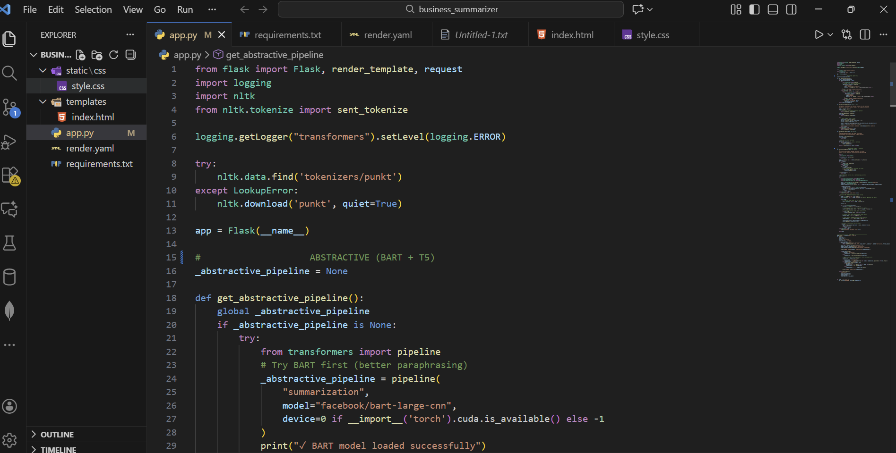
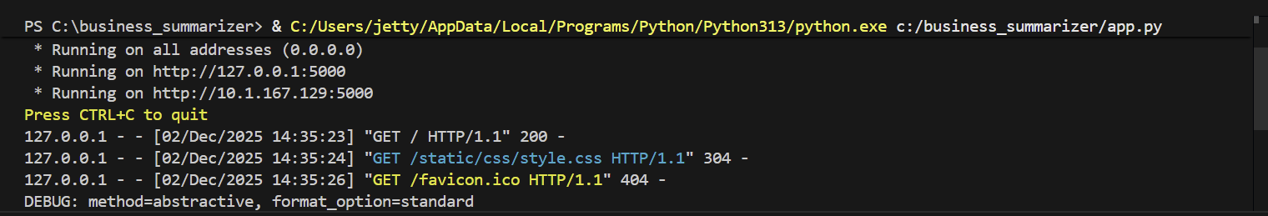
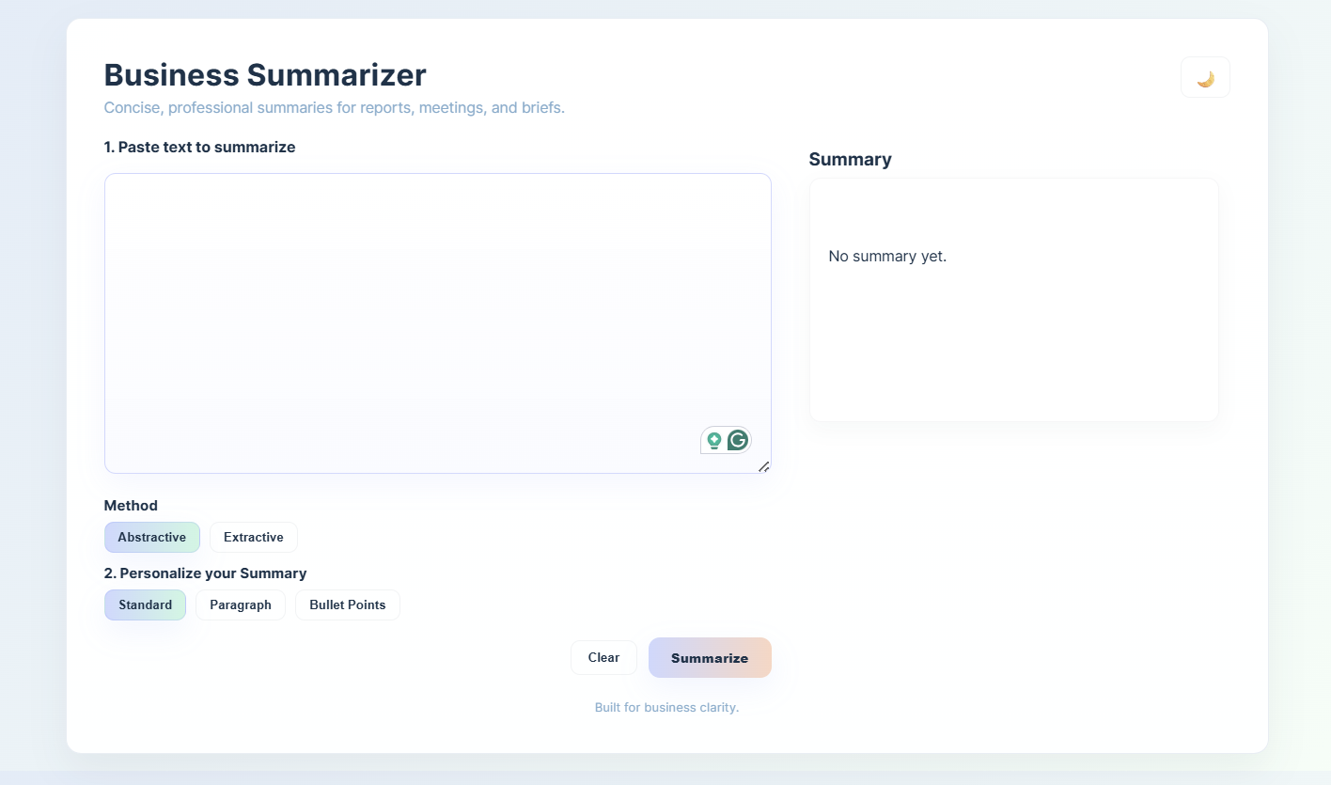
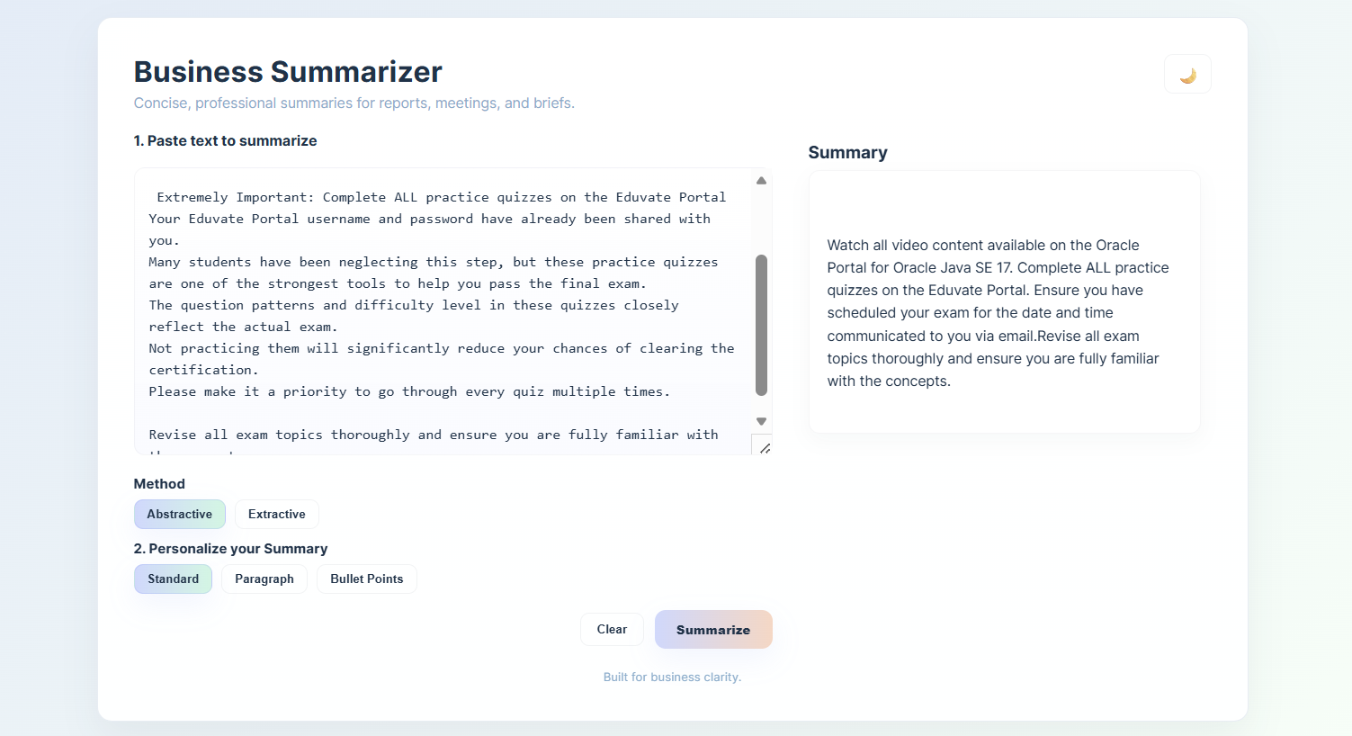

Future Implementations
To enhance the summarizer further, these upgrades can be added:

1. File Upload Support
- Upload PDF, DOCX, or TXT and summarize automatically.

2. Summary Length Slider
- Allow user to choose short / medium / long summaries.

3. Deployment on Render / Railway
- Host the web app online for public access.

4. Multi-language Summarization
- Add T5 multilingual or MBART.

5. Business Keyword Highlighting
- Highlight important keywords such as revenue, risk, forecast, profit, etc.

6. User Authentication
- Save summaries to user account.

Conclusion
The Business Summarizer project successfully implements both Extractive and
Abstractive summa rization techniques in a user-friendly web application.

Extractive (TextRank)
Provides factual summaries by selecting the most important sentences.

Abstractive (BART)
Generates new, meaningful, human-like summaries.

Flask Web App
Offers a clean and efficient interface to interact with the summarization engine.

Practical Usage
Ideal for students, professionals, researchers, and organizations dealing with large
volumes of text. The project demonstrates strong understanding of NLP,
Transformers, Deep Learning, Text Processing, and Full-stack Deployment,
proving its academic and real-world relevance.

